
DEPARTMENT OF INFORMATION AND COMMUNICATION TECHNOLOGY
LABORATORY TASK 5 | SESSION: 2 2024/2025

COURSE CODE: DFT40163 | COURSE NAME: WEB DESIGN TECHNOLOGY
CLO 1: Construct the HTML, CSS, JavaScript and jQuery in developing an interactive web page that can be published on web browser (P4, PLO 3)
TOPIC : 5.0 Web Mobile Framework

NAME :  1. NUR FAIZAH BINTI DALI  2. DHACYANI A/P MUNIANDY  3. NUR LIYANA BINTI MOHD ROSLAN |  | REGISTRATION NO :  1. 10DDT23F1069  2. 10DDT23F1502  3. 10DDT23F1087
CLASS :DDT4B |  | DURATION : 4 hours

CLO | MARKS
CLO 1P | /52
Total marks | /100

INSTRUCTION:
This laboratory task must be complete as a group consisting of 3-4 group members only. Read the QUESTIONS and refer to attached RUBRIC for MARKING SCHEME carefully.

LAB REPORT FORMAT
Content of the LAB REPORT:
The Lab Report must consist of ALL the question sheets, lab task rubric and all the answers which are arranged according to the page order as has been included.

Warning!
Marks will be deducted for any plagiarism from the total marks achieved.

Instructions:
You are required to construct a mobile-responsive website using the jQuery Mobile framework based on the given reference and the attached design sample (refer to the provided screenshot).
Main Source: https://demos.jquerymobile.com/1.2.0/

Objective
- To creatively apply jQuery Mobile components in building a mobile web application.
- To design a professional landing page for "Jabatan Teknologi Maklumat & Komunikasi (JTMK)".

Task (CLO2: P4)
Construct a mobile web landing page that includes the following components:

1. Header Section
- Organization logo on the left.
- Navigation bar on the right with links: HOME, ABOUT, PROJECTS, and CONTACT.
- The header must be sticky (fixed at the top) on all pages.

2. Main Content Sections

a) HOME Page
- A large introduction section with:
  - Heading: "HEY, MY NAME IS JTMK"
  - Sub-heading describing JTMK:
"JTMK is the Department of Information and Communication Technology (JTMK) offering DDT courses (Diploma in Information Technology (Digital Technology)) at Seberang Perai Polytechnic (PSP)."
- A button labeled "PROJECTS" that links to the Projects page.

b) ABOUT Page
- Details about all group members, assuming these roles:
  - Head of Department
  - Program Head (Software Track)
  - Program Head (Network Track)
  - Program Head (Data Track)
- Each member's profile must include:
  - Passport-sized photo
  - Full name
  - Position
  - Contact number

c) PROJECTS Page
- Create a list of projects with:
  - Project titles
  - Images
  - Reports in PDF format (clickable and viewable)
- Content must be creative and meaningful.

d) CONTACT Page
- Include functional buttons/links for:
  - Phone call (using tel: link)
  - Email (using mailto: link)
  - WhatsApp messaging (using WhatsApp API link)

3. Footer Section
- At the bottom of every page, display centered text:
"Copyright © DDT4x S2 2024/2025. All rights reserved."

4. Additional: Social Media Sidebar (Floating on Left)
- Display clickable icons vertically for:
  - LinkedIn
  - GitHub
  - Twitter
  - YouTube
  - Instagram
- Dummy links (#) are acceptable.

Requirements
- Apply jQuery Mobile components:
  - Header/Footer
  - Navigation Bar
  - Buttons
  - Listviews
  - Responsive Layouts (Grids)
- Apply Mobile Web Apps Architecture:
  - Use roles, theming, and page management.
- Manipulate Dialogs:
  - Apply dialog boxes where suitable according to creativity and page needs.
- Apply Hosting Resources:
  - Local Hosting: Host all files within the project folder (e.g., using FTP upload to web hosting like 000webhost, InfinityFree, GitHub Pages).
  - CDN Hosting: Use appropriate CDN links for libraries (e.g., jQuery, jQuery Mobile).
- Integrate jQuery Mobile lab activities previously done in class wherever relevant.

Deliverables
- Submit the complete project files:
  - HTML, CSS (if applicable), jQuery Mobile files.
- Must be tested and function correctly in both desktop browser and mobile view.
- Include a brief report containing:
  - URL of the developed website
  - Full source code
  - Screenshots of each page in responsive view (both desktop and mobile)
- Submit as a single compressed ZIP file.

Figure X: Sample Outcome for Homepage (without applying jQuery Mobile components)
This sample shows the homepage layout before integration of jQuery Mobile framework. It lacks mobile responsiveness, theming, and interactive jQuery Mobile elements.

INFORMATION AND COMMUNICATION TECHNOLOGY DEPARTMENT
LABORATORY TASK 5 RUBRIC | SESSION 2 2024/2025
COURSE CODE | DFT40163 | COURSE NAME | WEB DESIGN TECHNOLOGY
ASSESSMENT TASK | LAB TASK 5 | LECTURER’S NAME | PN. SHU HAILA BINTI MOHD YUSOF
REGISTRATION NUMBER | 1. 10DDT23F1069 | STUDENT’S NAME | 1. NUR FAIZAH BINTI DALI
 | 2. 10DDT23F1502 |  | 2. DHACYANI A/P MUNIANDY
 | 3. 10DDT23F1087 |  | 3. NUR LIYANA BINTI MOHD ROSLAN
 | 4 |  | 4

CATEGORY / SCORE | 4 (Excellent) |  | 3 (Good) |  | 2 (Fair) |  | 1 (Poor) | Weight (%) |  | Student Score  (1–4) |  | Marks (Student Score × Weight / Tot. Score)
Design & Layout | Excellent, professional layout; fully responsive and visually appealing |  | Good layout; responsive design with minor flaws |  | Basic structure; limited responsiveness; lacks polish |  | Very poor layout; no clear structure; lacks responsiveness | 15
Use of jQuery Mobile Components | Creative and full application of jQuery Mobile components with enhancements |  | Proper and consistent use of required components |  | Basic components used correctly, but inconsistent |  | Minimal or incorrect use of jQuery Mobile components | 15
Navigation Bar | Fully functional, user-friendly navigation. |  | Function with minor issues. |  | Basic structure, links may not work. |  | Missing or not functional. | 10
Social Media Sidebar (Floating on Left)) | All icons complete, linked correctly. |  | All icons are present and properly linked with minor errors |  | Some icons missing or not properly linked |  | Major icons missing or incomplete | 10
About Us Page Content | Complete, meaningful, professional content. |  | Complete but lacks some quality details. |  | Basic information included but incomplete. |  | Very incomplete or irrelevant. | 5
Project Page Content | Complete, creative, well-documented projects. |  | Good project list with images/PDFs. |  | Few projects with basic info. |  | Very little or no project info. | 5
Footer (Copyright & Alignment) | Footer perfectly formatted and centered. |  | Footer corrects with minor formatting issues. |  | Footer present but not properly centered. |  | Footer missing or incorrectly formatted. | 5
Padding and Margin (Navbar, Content, Footer) | Excellent and consistent padding/margin across pages. |  | Proper padding/margin but slight inconsistency. |  | Basic padding/margin but inconsistent. |  | No proper padding/margin settings. | 5
Direct Call, Email & WhatsApp Functions | All three functions were correctly implemented. |  | Two functions work properly. |  | Only one function works. |  | None implemented. | 5
Hosting (Project Files Hosted) | Properly hosted and fully functional project. |  | Hosting successful with minor issues. |  | Hosting done but many errors. |  | Files not hosted or broken hosting. | 10
CSS Application |  |  |  |  | Good CSS, improves layout. |  | Basic CSS, minimal styling. | 5
Use of CDN |  |  |  |  | Full and proper use of CDN links. |  | CDN used correctly but minor errors. | 5
Report Submission (URL, Source Code, Screenshots) |  |  |  |  | Full report: URL, complete source code, and all responsive screenshots included properly |  | Report submitted but incomplete (missing screenshots/code) | 5
Task Completion within Time Allocated |  |  |  |  | Completed on time, high-quality submission. |  | Late submission but acceptable quality. | 5
TOTAL SCORE ( / 100)
Note: A mark of ZERO (0) will be given if all items for score 1-4 are NOT fulfilled as specified or NO answer is given by the student.

~End of Question~

Answer Sheet:

Hosting (Project Files Hosted)
URL address:

Coding
Note: Font Type Consolas 10pt, Single Spacing
Specify the name of the html file followed by coding.

home.html
<!DOCTYPE html>
<html lang="en">
<head>
<meta charset="UTF-8">
<meta name="viewport" content="width=device-width, initial-scale=1, maximum-scale=1, user-scalable=no">
<title>JTMK Home</title>
<link rel="stylesheet" href="https://code.jquery.com/mobile/1.4.5/jquery.mobile-1.4.5.min.css" />
<link rel="stylesheet" href="style.css">
<script src="https://code.jquery.com/jquery-3.6.0.min.js"></script>
<script src="https://code.jquery.com/mobile/1.4.5/jquery.mobile-1.4.5.min.js"></script>
</head>
<body>

<div data-role="page" id="home">
<header data-role="header">
<div class="logo">JTMK</div>
<nav>
<a href="home.html" data-role="button">HOME</a>
<a href="about.html" data-role="button">ABOUT</a>
<a href="projects.html" data-role="button">PROJECTS</a>
<a href="contact.html" data-role="button">CONTACT</a>
</nav>
</header>

<div class="social-sidebar">
<a href="https://www.linkedin.com" data-role="button"><img src="images/linkedin.png" alt="LinkedIn"></a>
<a href="https://github.com" data-role="button"><img src="images/github.png" alt="GitHub"></a>
<a href="https://twitter.com" data-role="button"><img src="images/twitter.png" alt="Twitter"></a>
<a href="https://www.youtube.com" data-role="button"><img src="images/youtube.png" alt="YouTube"></a>
<a href="https://www.instagram.com" data-role="button"><img src="images/ig.png" alt="Instagram"></a>
</div>

<main role="main" class="ui-content">
<section id="home" style="text-align: center;">
<h1>HEY, MY NAME IS JTMK</h1>
<p>JTMK is the Department of Information and Communication Technology (JTMK) offering DDT courses (Diploma in Information Technology (Digital Technology)) at Seberang Perai Polytechnic (PSP).</p>
<a href="projects.html" class="btn-projects" data-role="button">PROJECTS</a>
</section>
</main>

<footer data-role="footer" data-position="fixed">
<p>Copyright © DDT4B S2 2024/2025. All rights reserved.</p>
</footer>
</div>

<script src="script.js"></script>
</body>
</html>

about.html
<!DOCTYPE html>
<html lang="en">
<head>
<meta charset="UTF-8">
<meta name="viewport" content="width=device-width, initial-scale=1, maximum-scale=1, user-scalable=no">
<title>About JTMK</title>
<link rel="stylesheet" href="https://code.jquery.com/mobile/1.4.5/jquery.mobile-1.4.5.min.css" />
<link rel="stylesheet" href="style.css">
<script src="https://code.jquery.com/jquery-3.6.0.min.js"></script>
<script src="https://code.jquery.com/mobile/1.4.5/jquery.mobile-1.4.5.min.js"></script>
</head>
<body>

<div data-role="page" id="about">
<header data-role="header">
<div class="logo">JTMK</div>
<nav>
<a href="home.html" data-role="button">HOME</a>
<a href="about.html" data-role="button">ABOUT</a>
<a href="projects.html" data-role="button">PROJECTS</a>
<a href="contact.html" data-role="button">CONTACT</a>
</nav>
</header>

<div class="social-sidebar">
<a href="https://www.linkedin.com" data-role="button"><img src="images/linkedin.png" alt="LinkedIn"></a>
<a href="https://github.com" data-role="button"><img src="images/github.png" alt="GitHub"></a>
<a href="https://twitter.com" data-role="button"><img src="images/twitter.png" alt="Twitter"></a>
<a href="https://www.youtube.com" data-role="button"><img src="images/youtube.png" alt="YouTube"></a>
<a href="https://www.instagram.com" data-role="button"><img src="images/ig.png" alt="Instagram"></a>
</div>

<main role="main" class="ui-content">
<section id="about">
<div class="member-card">
<img src="images/img1.jpeg" alt="Member 1"/>
<div class="member-info">
<h3>NUR FAIZAH BINTI DALI</h3>
<p>Head of Department</p>
<p>+60 011-1310 2752</p>
</div>
</div>
<div class="member-card">
<img src="images/img2.png" alt="Member 2"/>
<div class="member-info">
<h3>DHACYANI A/P MUNIANDY</h3>
<p>Program Head (Software Track)</p>
<p>+60 11-5588 9136</p>
</div>
</div>
<div class="member-card">
<img src="images/img3.jpg" alt="Member 3"/>
<div class="member-info">
<h3>NUR LIYANA BINTI MOHD ROSLAN</h3>
<p>Program Head (Network Track)</p>
<p>+60 17-471 8057</p>
</div>
</div>
</section>
</main>

<footer data-role="footer" data-position="fixed">
<p>Copyright © DDT4B S2 2024/2025. All rights reserved.</p>
</footer>
</div>

<script src="script.js"></script>
</body>
</html>

projects.html
<!DOCTYPE html>
<html lang="en">
<head>
<meta charset="UTF-8">
<meta name="viewport" content="width=device-width, initial-scale=1, maximum-scale=1, user-scalable=no">
<title>JTMK Projects</title>
<link rel="stylesheet" href="https://code.jquery.com/mobile/1.4.5/jquery.mobile-1.4.5.min.css" />
<link rel="stylesheet" href="style.css">
<script src="https://code.jquery.com/jquery-3.6.0.min.js"></script>
<script src="https://code.jquery.com/mobile/1.4.5/jquery.mobile-1.4.5.min.js"></script>
</head>
<body>

<div data-role="page" id="projects-page">
<header data-role="header">
<div class="logo">JTMK</div>
<nav>
<a href="home.html" data-role="button">HOME</a>
<a href="about.html" data-role="button">ABOUT</a>
<a href="projects.html" data-role="button">PROJECTS</a>
<a href="contact.html" data-role="button">CONTACT</a>
</nav>
</header>

<div class="social-sidebar">
<a href="https://www.linkedin.com" data-role="button"><img src="images/linkedin.png" alt="LinkedIn"></a>
<a href="https://github.com" data-role="button"><img src="images/github.png" alt="GitHub"></a>
<a href="https://twitter.com" data-role="button"><img src="images/twitter.png" alt="Twitter"></a>
<a href="https://www.youtube.com" data-role="button"><img src="images/youtube.png" alt="YouTube"></a>
<a href="https://www.instagram.com" data-role="button"><img src="images/ig.png" alt="Instagram"></a>
</div>

<main role="main" class="ui-content">
<section id="project-list">
<div class="project-item">
<h4>Inventory Web System</h4>
<img src="images/Inventory Web System.png" alt="Web Development Report" />
<a href="Web_Based_Online_Inventory_Information_System.pdf" class="pdf-link" target="_blank" rel="noopener" data-role="button">View Report (PDF)</a>
</div>

<div class="project-item">
<h4>Network Simulation</h4>
<img src="images/Advances_in_Network_Simulation..png" alt="Presentation Slide" />
<a href="Advances_in_Network_Simulation.pdf" class="pdf-link" target="_blank" rel="noopener" data-role="button">View Report (PDF)</a>
</div>

<div class="project-item">
<h4>AI-Controlled Robotic Arm</h4>
<img src="images/robotic_arm.jpg" alt="Robotic Arm Project" />
<a href="robotic_arm_report.pdf" class="pdf-link" target="_blank" rel="noopener" data-role="button">View Report (PDF)</a>
</div>
</section>
</main>

<footer data-role="footer" data-position="fixed">
<p>Copyright © DDT4B S2 2024/2025. All rights reserved.</p>
</footer>
</div>

<script src="script.js"></script>
</body>
</html>

contact.html
<!DOCTYPE html>
<html lang="en">
<head>
<meta charset="UTF-8">
<meta name="viewport" content="width=device-width, initial-scale=1, maximum-scale=1, user-scalable=no">
<title>Contact JTMK</title>
<link rel="stylesheet" href="https://code.jquery.com/mobile/1.4.5/jquery.mobile-1.4.5.min.css" />
<link rel="stylesheet" href="style.css">
<script src="https://code.jquery.com/jquery-3.6.0.min.js"></script>
<script src="https://code.jquery.com/mobile/1.4.5/jquery.mobile-1.4.5.min.js"></script>
</head>
<body>

<div data-role="page" id="contact">
<header data-role="header">
<div class="logo">JTMK</div>
<nav>
<a href="home.html" data-role="button">HOME</a>
<a href="about.html" data-role="button">ABOUT</a>
<a href="projects.html" data-role="button">PROJECTS</a>
<a href="contact.html" data-role="button">CONTACT</a>
</nav>
</header>

<div class="social-sidebar">
<a href="https://www.linkedin.com" data-role="button"><img src="images/linkedin.png" alt="LinkedIn"></a>
<a href="https://github.com" data-role="button"><img src="images/github.png" alt="GitHub"></a>
<a href="https://twitter.com" data-role="button"><img src="images/twitter.png" alt="Twitter"></a>
<a href="https://www.youtube.com" data-role="button"><img src="images/youtube.png" alt="YouTube"></a>
<a href="https://www.instagram.com" data-role="button"><img src="images/ig.png" alt="Instagram"></a>
</div>

<main role="main" class="ui-content">
<section id="contact" style="text-align:center;">
<a href="tel:+601113102752" class="contact-btn" data-role="button">Call Us</a>
<a href="mailto:nurliyanaerc@gmail.com" class="contact-btn" data-role="button">Email Us</a>
<a href="https://wa.me/601155889136" class="contact-btn" data-role="button">WhatsApp Us</a>
</section>
</main>

<footer data-role="footer" data-position="fixed">
<p>Copyright © DDT4B S2 2024/2025. All rights reserved.</p>
</footer>
</div>

<script src="script.js"></script>
</body>
</html>

style.css
* {
box-sizing: border-box;
margin: 0;
padding: 0;
}
body {
font-family: Arial, sans-serif;
background: linear-gradient(to bottom, #f9f9f9, #e6f0ff);
color: #333;
display: flex;
flex-direction: column;
min-height: 100vh;
}
header {
position: sticky;
top: 0;
width: 100%;
background: #fff;
box-shadow: 0 2px 4px rgba(0, 0, 0, 0.05);
display: flex;
justify-content: space-between;
align-items: center;
padding: 10px 15px;
flex-wrap: wrap;
}

header .logo {
font-weight: bold;
font-size: 1.2em;
color: #0073e6;
}

nav {
display: flex;
flex-wrap: wrap;
justify-content: flex-end;
flex: 1;
min-width: 0;
}

nav a {
text-decoration: none;
color: #333;
margin-left: 15px;
font-weight: 600;
font-size: 1em;
white-space: nowrap;
}

nav a:hover {
color: #0073e6;
}

main {
max-width: 600px;
margin: 20px auto;
padding: 0 15px;
flex: 1;
}

#home {
text-align: center;
padding: 40px 20px;
background: #e6f0ff;
border-radius: 8px;
margin-bottom: 30px;
}
#home h1 {
font-size: 2em;
margin-bottom: 10px;
color: #004080;
}

#home p {
font-size: 1em;
margin-bottom: 20px;
}

#home .btn-projects {
display: inline-block;
background: #0073e6;
color: white;
padding: 12px 25px;
border-radius: 25px;
font-weight: bold;
text-decoration: none;
font-size: 1em;
transition: background 0.3s ease;
}

#home .btn-projects:hover {
background: #005bb5;
}

#about {
margin-bottom: 30px;
}

.member-card {
background: white;
border-radius: 8px;
box-shadow: 0 2px 6px rgba(0, 0, 0, 0.1);
padding: 15px;
margin-bottom: 20px;
display: flex;
align-items: center;
gap: 15px;
}

.member-card img {
width: 80px;
height: 100px;
object-fit: cover;
border-radius: 4px;
border: 1px solid #ccc;
}

.member-info h3 {
margin-bottom: 5px;
color: #0073e6;
}

.member-info p {
font-size: 0.9em;
color: #555;
}

#projects {
margin-bottom: 30px;
}

.project-item {
background: white;
border-radius: 8px;
box-shadow: 0 2px 6px rgba(0, 0, 0, 0.1);
margin-bottom: 20px;
padding: 15px;
}

.project-item img {
width: 100%;
max-height: 180px;
object-fit: cover;
border-radius: 4px;
margin-bottom: 10px;
}

.project-item h4 {
margin-bottom: 8px;
color: #0073e6;
}

.project-item a.pdf-link {
display: inline-block;
background: #0073e6;
color: white;
padding: 8px 15px;
border-radius: 20px;
text-decoration: none;
font-weight: bold;
font-size: 0.9em;
transition: background 0.3s ease;
}

.project-item a.pdf-link:hover {
background: #005bb5;
}

#contact {
text-align: center;
margin-bottom: 30px;
}

.contact-btn {
display: inline-block;
background: #0073e6;
color: white;
padding: 12px 25px;
border-radius: 25px;
font-weight: bold;
text-decoration: none;
font-size: 1em;
margin: 10px;
transition: background 0.3s ease;
}

.contact-btn:hover {
background: #005bb5;
}

footer {
text-align: center;
padding: 15px 10px;
background: #f0f8ff;
font-size: 0.9em;
color: #666;
width: 100%;
}

section {
background: #ffffff;
border-radius: 8px;
box-shadow: 0 2px 4px rgba(0, 0, 0, 0.1);
padding: 20px;
margin-bottom: 20px;
}

.social-sidebar {
position: fixed;
left: 10px;
top: 50%;
transform: translateY(-50%);
display: flex;
flex-direction: column;
gap: 15px;
z-index: 1100;
}

.social-sidebar a img {
width: 40px;
height: 40px;
border-radius: 50%;
}

.social-sidebar a:hover {
transform: scale(1.1);
background-color: #005582;
}

@media (max-width: 600px) {
header {
flex-direction: column;
align-items: flex-start;
padding: 10px;
}

nav {
justify-content: center;
margin-top: 10px;
width: 100%;
}

nav a {
margin: 5px 10px;
font-size: 1.1em;
}

main {
max-width: 100%;
margin: 10px;
padding: 0 10px;
}

.member-card {
flex-direction: column;
text-align: center;
}

.social-sidebar {
left: 5px;
}

.social-sidebar a {
width: 35px;
height: 35px;
line-height: 35px;
font-size: 18px;
}
}

@media (max-width: 480px) {
header {
justify-content: center;
padding: 10px;
}

nav {
margin-top: 8px;
}
}

script.js
<script>
document.addEventListener("DOMContentLoaded", function() {
const navLinks = document.querySelectorAll("nav a");
const currentPage = window.location.pathname.split('/').pop().replace('.html','');
navLinks.forEach(link => {
if (link.getAttribute("href").includes(currentPage) || (currentPage === "" && link.getAttribute("href") === "home.html")) {
link.style.color = "#0073e6";
}
});
});

</script>

Screenshot Interface:

Home
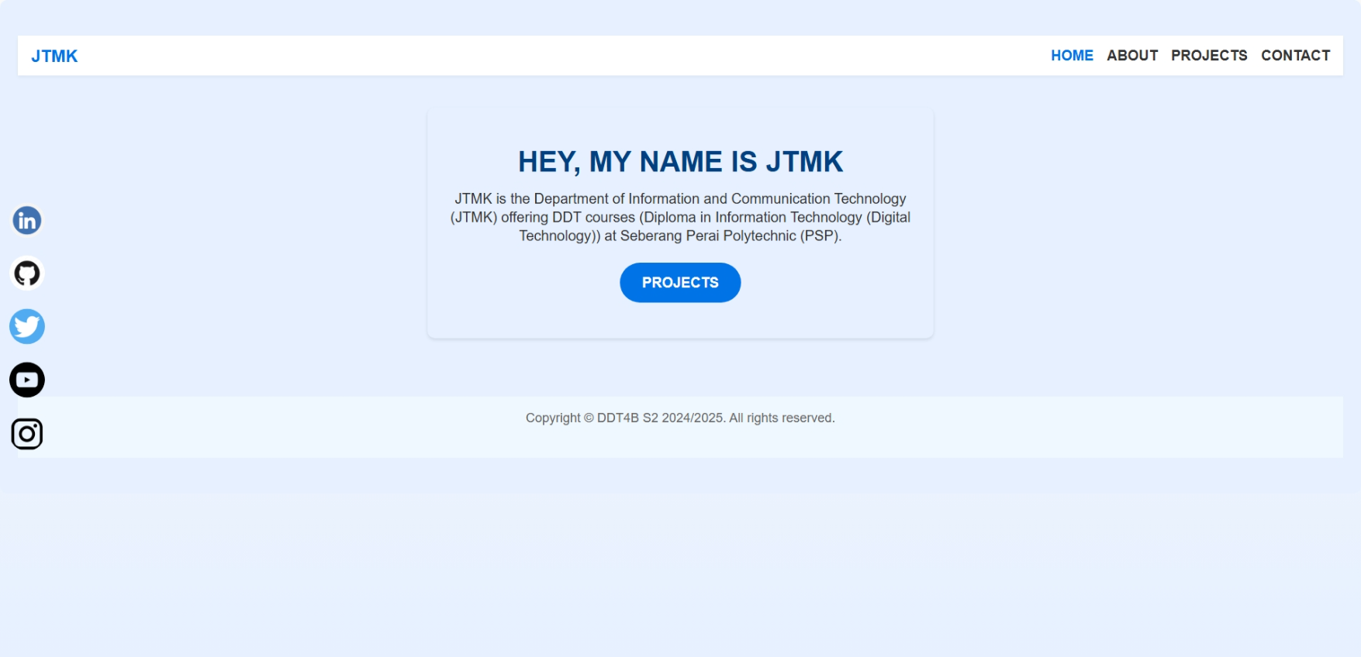

about
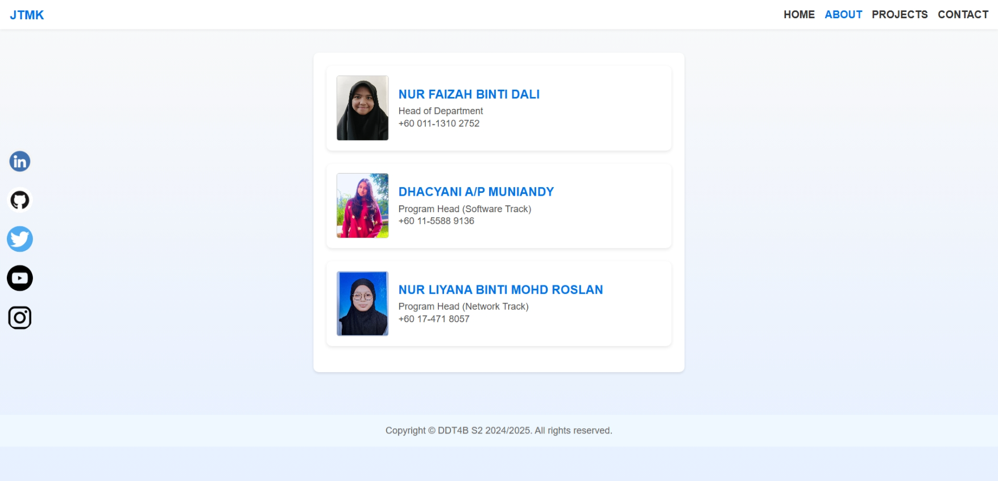

projects
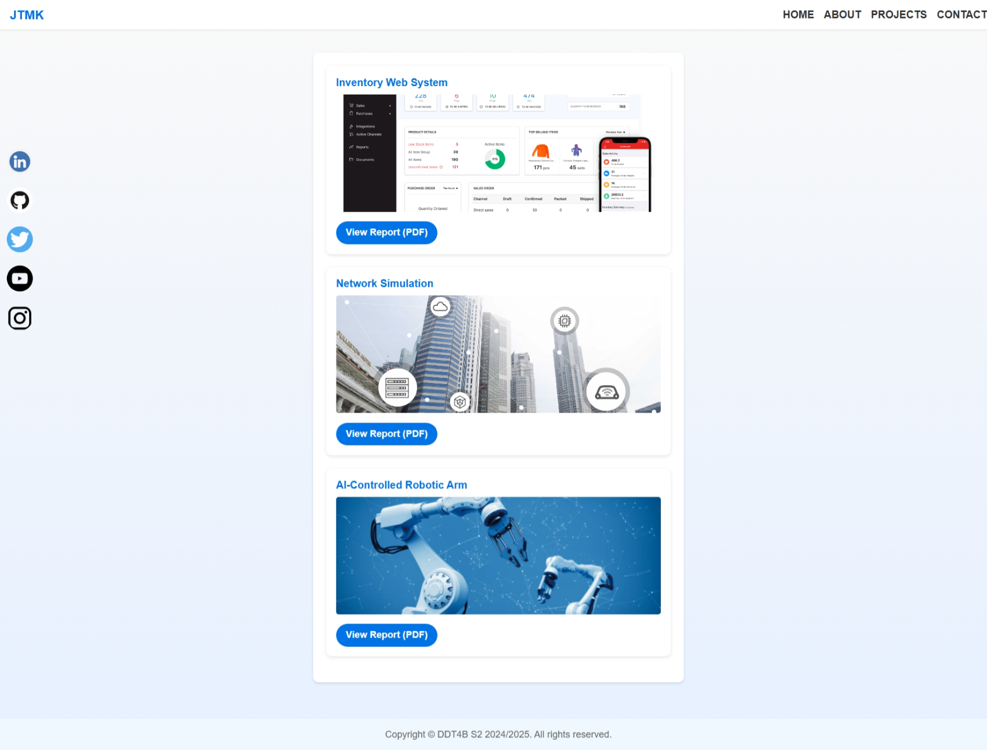

contact
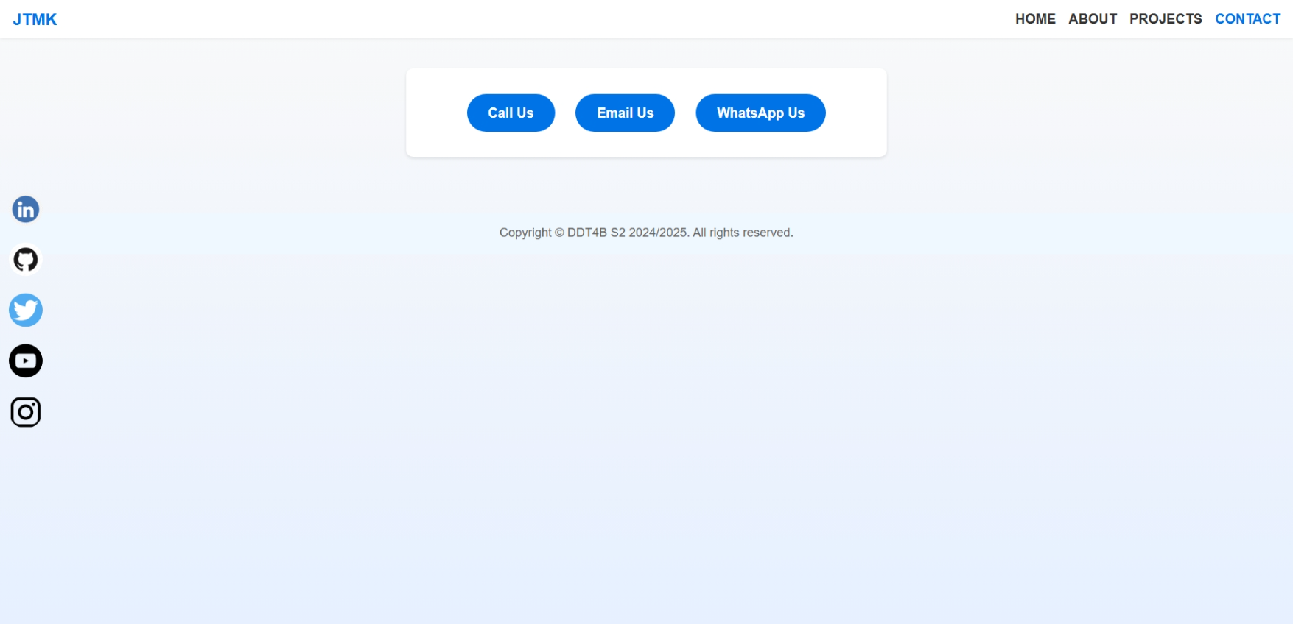

Direct Call, Email & WhatsApp Functions

Link tel
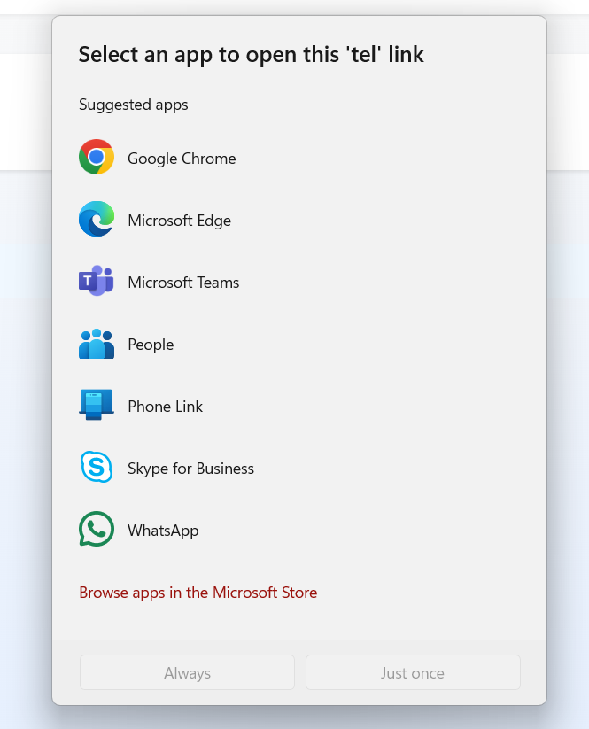
WhatsApp
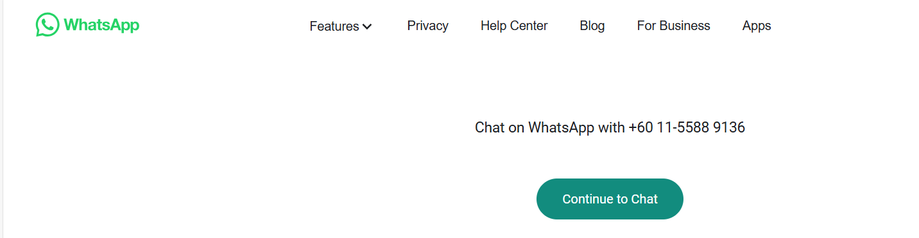

email
